**PROJECT REPORT**

**Predicting Life Expectancy using Machine learning**

**By**

Ms. Hemlata Ahire

K. K. Wagh institute of engineering education and research, Nashik

Email: [ahirehemlata2000@gmail.com](mailto:ahirehemlata2000@gmail.com)

**Under the guidance of**

The SmartBridge

Table of contents Pg. No

1. INTRODUCTION ------------------------------------------------------------ 3
   1. Overview----------------------------------------------------------------3
   2. Purpose------------------------------------------------------------------3
2. LITERATURE SURVEY---------------------------------------------------- 3
   1. Existing problem------------------------------------------------------ 3
   2. Proposed solution-----------------------------------------------------4
3. THEORITICAL ANALYSIS-------------------------------------------------5
   1. Block diagram----------------------------------------------------------5
   2. Hardware / Software designing-------------------------------------5
4. EXPERIMENTAL INVESTIGATIONS------------------------------------6
5. FLOWCHART----------------------------------------------------------------- 8
6. RESULT-------------------------------------------------------------------------9
7. ADVANTAGES & DISADVANTAGES-----------------------------------9
8. APPLICATIONS---------------------------------------------------------------9
9. CONCLUSION-----------------------------------------------------------------10
10. FUTURE SCOPE---------------------------------------------------------------10
11. BIBILOGRAPHY---------------------------------------------------------------10
12. APPENDIX----------------------------------------------------------------------11
13. SOURCE CODE----------------------------------------------------------------11
14. **INTRODUCTION**

**1.1 Overview:**

It’s no secret, though, that life expectancy varies widely across the globe. Life expectancy is one of the most important factors in end-of-life decision making. Good prognostication for example helps to determine the course of treatment and helps to anticipate the procurement of health care services and facilities, or more broadly: facilitates Advance Care Planning.

Life expectancy is a statistical measure of the average time of human being is expected to live. As if average time of human being is expected to live can be calculated then we can predict the average rate of life expectancy of country. Life expectancy depends on various factors like Regional variations, Economic Circumstances, Sex differences, Mental Illnesses, Physical Illnesses, Education, Year of their birth and other demographic factors. In this project life expectancy rate of country will be predicted.

In this project various factors such as GDP, education, alcohol intake people of in the country, expenditure on healthcare system and some specific disease related deaths that happened in the country are considered as input. By using this factors rate of life expectancy of country will be predicted.

**1.2 Purpose:**

Predicting Life Expectancy using Machine Learning. A typical Regression Machine Learning project leverages historical data to predict insights into the future. This problem statement is aimed at predicting Life Expectancy rate of a country given various features.

The purpose of project is help to country to know their rate of life expectancy, which factors affects more to decrease life expectancy so that they can take appropriate decision to increase life expectancy of human being in their country.

1. **LITERATURE SURVEY** 
   1. **Existing Problem :**

Country must know about Life Expectancy of their country. If country know about their life expectancy they can understand which factors affects more to decrease life expectancy of their country, so that they can take appropriate decision to increase life expectancy of human being in their country.

* 1. **Proposed Solution :**

Predicting life Expectancy using Machine Learning project will help country to know their life expectancy.so that they can understand which factors affects more to decrease life expectancy of their country, so that they can take appropriate decision to increase life expectancy of human being in their country.

This project takes following aspects (features) as input:

1. Country
2. Year
3. Status
4. Adult Mortality
5. Alcohol
6. percentage expenditure
7. Hepatitis B
8. Measles
9. BMI
10. under-five deaths
11. Polio
12. Total expenditure
13. Diphtheria
14. HIV/AIDS
15. GDP
16. Population
17. thinness 1-19 years
18. thinness 5-9 years
19. Income composition of resources
20. Schooling

Target is Life Expectancy, measured in number of years.

The assumptions are:

1. These are country level average
2. There is no distinction between male and female.

**3. THEORITICAL ANALYSIS:**

**3.1 Block Diagram:**

**Input all the I/P Factors**

**Test Dataset**

**Data Pre-processing**

**Model**

**Extra Tree Regressor Algorithm**

**Training Dataset**

**Prediction**

**3.2 Hardware / Software Designing:**

Hardware:

* Internal hardware devices include Motherboard, Hard-Drives, and RAM.
* External hardware devices include Monitor, keyboard, and mouse.

Software:

* IBM cloud Software :

-Node-Red App [Webpage].

-Watson Studio [Algorithms]

-Machine Learning

* Programming Environment :

-Default Python 3.6 XS

**4. EXPERIMENTAL INVESTIGATIONS**

Some random inputs are given to the deployed machine learning model. We got the following output.

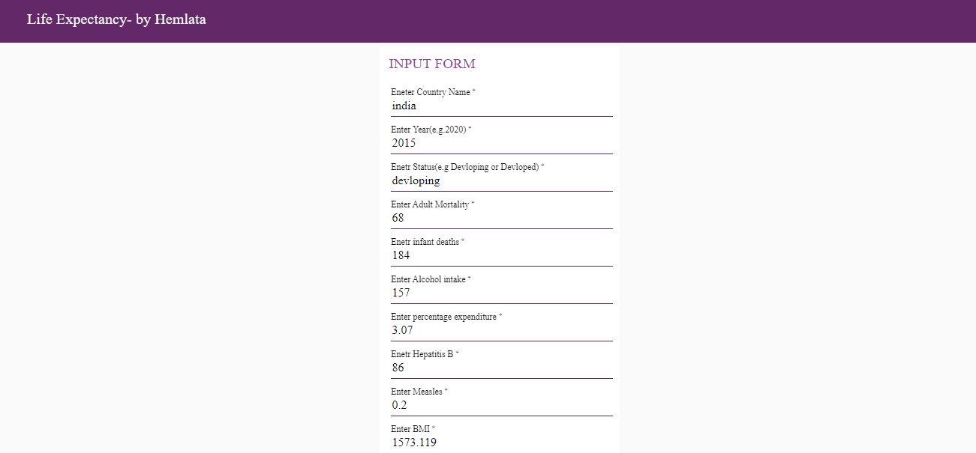

**5. FLOWCHART:**

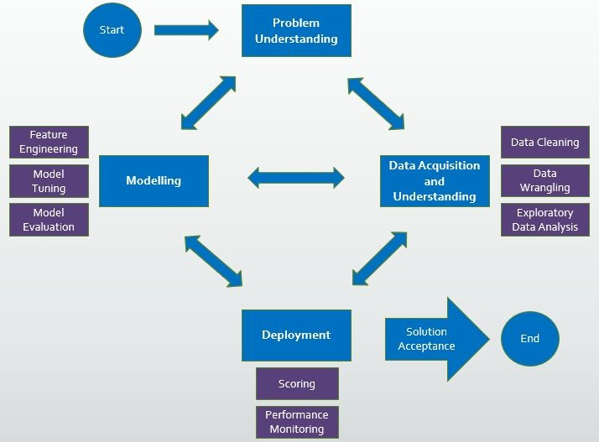

**6. RESULT:**

Based on the given data, the auto AI understands the data and cross references the data to watch what are the factors that are affecting the results we require that is life expectancy.

Then when we give any input, it has already run algorithm to get the output based on previously given data. So the results we get are approximations, they are not definitely true, but it works in maximum number of cases, except for some exceptional ones.

**7. ADVANTAGES AND DISADVANTAGES**

**Advantages:**

* So, therefore by trying to change those factors in the real world we can increase the life span.
* Since we can predict the life span, we can know what factors are influencing the expectancy on life span in what ways.

**Disadvantages:**

* Predictions are not definitely true, but it works in maximum number of cases, except for some exceptional ones.

**8. APPLICATION**

* Country can analyse what factors affects more to increase life expectancy.
* Country can also analyse which factors affects more to decrease life expectancy so that they can take appropriate decision to increase life expectancy of human being in their country.
* Predicting life expectancy will help to country to know their average rate of life expectancy.

**9. CONCLUSION**

Predicting Life Expectancy using Machine Learning project will help country to know their life expectancy.

**10. FUTURE SCOPE**

The problem of processing datasets such as electronic medical records (EMR) and their integration with genomics, environmental factors, socioeconomic factor and patient behavior variations have posed a problem for researchers the health industry. Due to rapid innovations in machine learning field such as big data, analytics, visualization, deep learning, health workers now have improved way of processing, and developing meaningful information from huge datasets that have been accumulated over many years.

Big data and machine learning can benefit public health researchers with analyzing thousands of variables to obtain data regarding life expectancy. We can use demographics of selected regional areas and multiple behavioral health disorders across regions to find correlation between individual behavior indicators and behavioral health outcomes.

**11. BIBILOGRAPHY**

* <https://www.kaggle.com/kumarajarshi/life-expectancy-who>
* <https://www.youtube.com/watch?v=DBRGlAHdj48&list=PLzpeuWUENMK2PYtasCaKK4bZjaYzhW23L>
* <https://www.youtube.com/watch?v=-CUi8GezG1I&list=PLzpeuWUENMK2PYtasCaKK4bZjaYzhW23L&index=2>
* <https://bookdown.org/caoying4work/watsonstudio-workshop/auto.html#add-asset-as-auto-ai>

**12. APPENDIX**

* 1. **Source Code :**